QHLL Families:
Thank you for your patience- We are excited to announce that Spring 2024 registration is OPEN! Save $25 with early-bird pricing for all divisions through Halloween! ***Registration must be paid in full by October 31st to take advantage of the $25 early bird special!
We are registering for tee-ball, coach pitch, farm, minor, and major baseball. ***Junior baseball, Senior baseball, Junior softball and Senior softball- Based on number of interests these divisions may combine play with other leagues to form teams and will travel to other locations for all games and practices. Also, depending on numbers for minor and major softball, teams may interleague or play at other fields or combine play to form teams. ***If you are interested in managing or coaching please email info@qhll.org
Please register or log into your existing account at www.qhll.org to ensure your address, phone number, email, and player's information is up to date. To ensure you have the appropriate documents ready for registration, please review the Little League Residency checklist here. If you are unsure if you live in our boundaries, you can check your address here. Document collection will be in person only! Dates TBD.
***Please bring I.D, birth certificate, signed concussion information sheet, medical release, three proofs of residency or the school verification form. Forms are available at www.qhll.org under "Important Forms"
The school verification form is the easiest way to prove residency! Print and have your school administrator sign it now. This eliminates having to bring 3 proofs of residency!
Tee-Ball and Coach Pitch
Registration: $125.00 PLUS a $50.00 Snack Bar Deposit (Refundable when shift is worked) PLUS $30.00 for Opportunity Tickets (6 tickets - valid for Opening Ceremonies raffle. May be resold for $5 each.)
Softball and Farm and above baseball-
Registration: $200.00 PLUS a $50.00 Snack Bar Deposit (Refundable when shift is worked) PLUS $30.00 for Opportunity Tickets (6 tickets - valid for Opening Ceremonies raffle. May be resold for $5 each.)
Tee-ball: league ages (*3 1/2 -5)
Coach Pitch: league ages (5-6)
Farm: league ages (7-8)
Minor baseball: league ages (9-10)
Major baseball: league ages (11-12)
Junior baseball: league ages (12-15)
Senior baseball: league ages (12-16)
Minor softball: league ages (7-8-9)
Major softball: league ages (10-12)
Junior softball: league ages (12-14)
Senior softball: league ages (15-16)
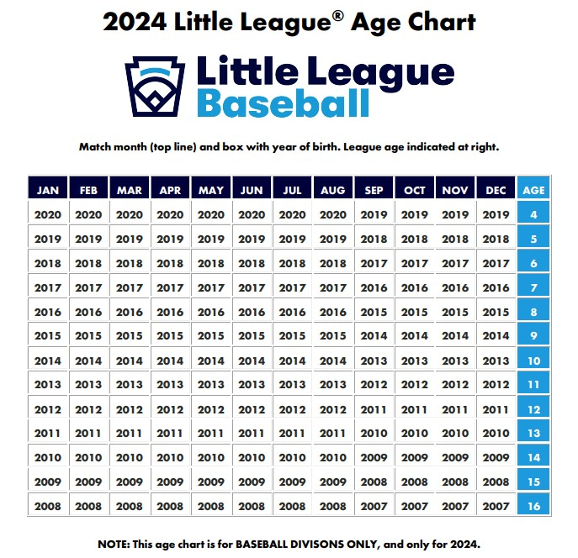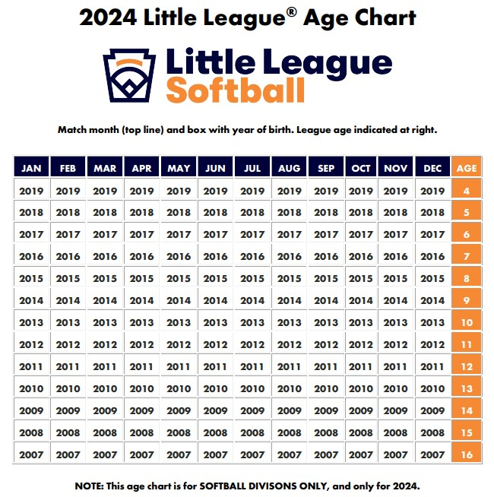
If you have any questions about registration please email registrar@qhll.org
All other questions please email info@qhll.org

Quartz Hill Little League

